Training materials to discipline Risk management of transgenes

Socio-economic / bioethical issues Risks of GM Crops Food safety Ecological effects Management effects Genetic effects of transformation

2. Rescuers use explosives to blast an escape tunnel to free two Australian miners trapped underground Lebanese firefighter extinguishes body of truck driver, killed by Israeli planes in attack on Beirut, 17 July 2006 Most major technologies have benefits & risks Canada assesses the risks of the trait (e.g. herbicide tolerance) regardless of the technology Europe assesses the risks of the technology regardless of the trait. Assessment of benefit is disallowed Directive 2001/18 & Regulation 1829/2003

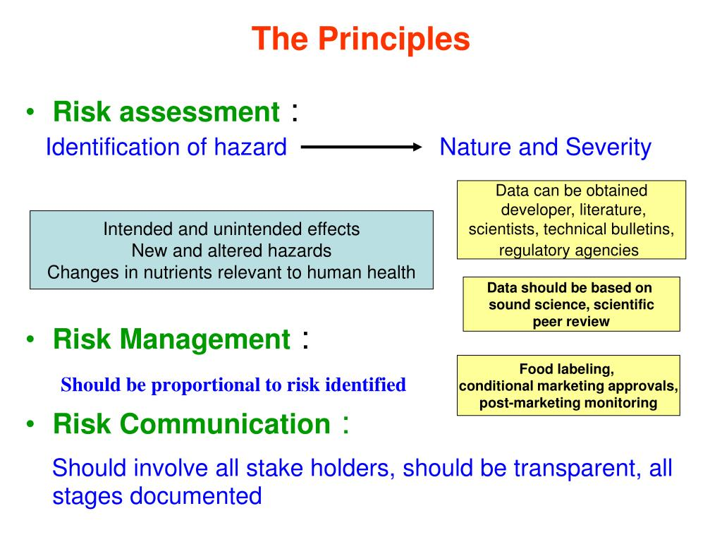

3. EFSA: Committed since 2002 to ensuring that Europe’s food is safe EFSA GMO Panel 2009 - 2012 21 experts - independent academics
4. EFSA’s role in GMO applications In the EU, products that are, contain, or are produced from GMOs must have an authorisation at the Community level prior to entering the market. • Protection ¬ Human and animal health ¬ Environment • Risk assessment (RA) ¬ Characterisation of potential adverse effects associated with GM plant deployment/use – Direct; indirect; immediate; delayed; cumulative effects
5. EFSA advises – European Union decides • 27 EU Member States vote on approvals of GMOs • Need qualified majority • Despite WTO rules - votes are on political basis • Qualified majority not usually obtained, especially for cultivation • Then European Commission (DG SANCO) have to decide
6. Member states voting patterns on GMOs

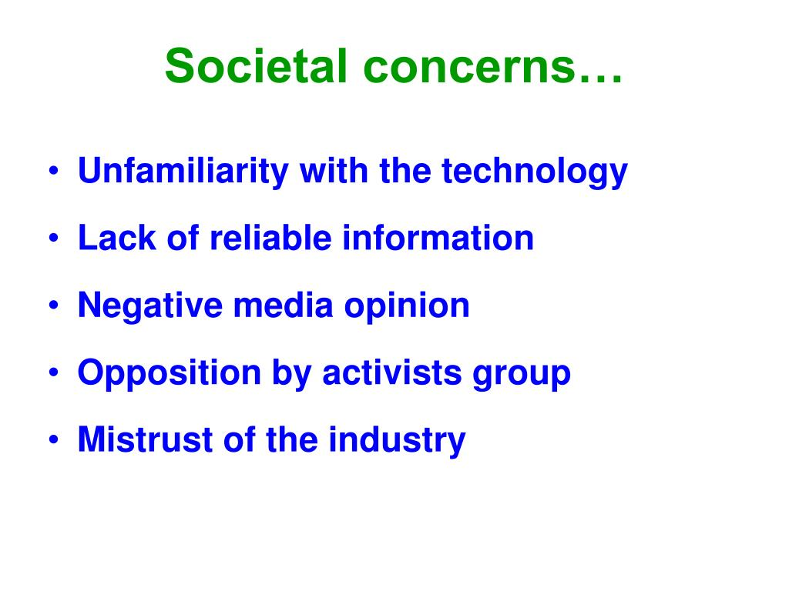
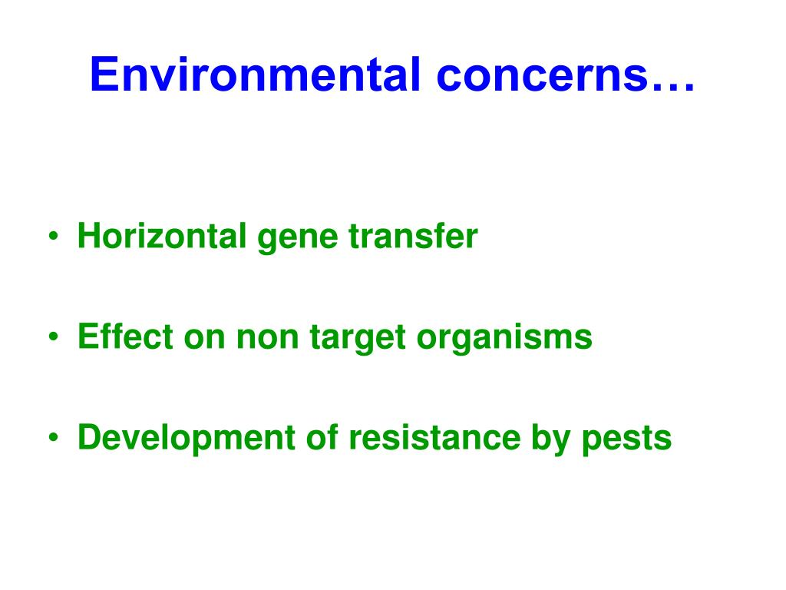

7. Number of approved GM products in EU, US, Brazil and Canada
8. Average duration of authorization of GM food-feed imported product (not for cultivation) in the EU
9. Scope of GMO applications Food • GMO for food use • Food containing or consisting of GMOs • Food produced from or containing ingredients produced from GMO Feed • GMO for feed use • Feed containing or consisting of GMOs • Feed produced from GMOs Deliberate release into the environment • Import and processing • Seeds and plant propagation material for cultivation EFSA carries out scientific risk assessment on GMOs to conclude on whether they are as safe as their conventional equivalents
10. For risk assessment, the average dossier of information supplied by a company seeking to import GM food into the EU comprises 2000 pages of evidence (does not all fit onto one CD) “not by any to be enterprised, nor taken in hand unadvisedly, lightly, or wantonly; but reverently, discreetly, soberly, and in the fear of God”
11. EFSA GMO Panel expertise MOLECULAR CHARACTERISATION • biochemistry • molecular biology • genetics • plant breeding • microbiology FOOD FEED SAFETY • toxicology • immunology • nutrition & animal feed • food chemistry • biotechnology ENVIRONMENTAL RISK ASSESSMENT • plant biology • ecology • agronomy • entomology • biometrics & statistics Working groups with Ad-hoc experts in new techniques Working Groups with Ad-hoc experts in pesticides, natural toxins, environmental monitoring Working groups with Ad-hoc experts in food sciences, animal pathology •14 EFSA staff scientistes •70 ad hoc experts •210 MS experts from 108 organisations and authorities of EU Member States EFSA GMO Panel of 19 external experts Renewed every 3 years
12. GM: 130 Non-GM comparator: 115 Compositional analysis The comparative approach A test of difference: GMO vs near-isogenic comparator 100 150 200 endpoint Aendpoint A 100 150 200
13. GM: 130 The principle of a ‘history of safe use’ Commercial varieties endpoint A 100 150 200
14. Commercial varieties form a distribution leads to an equivalence test (cf pharmaceutical risk assessment) Commercial varieties: μ=125 ; σ=15 endpoint A 100 125 150
15. What is the (statistical) power of an experiment? • Usually in biology we set up a null hypothesis of equality and try to disprove it in order to demonstrate an effect. • Power is the probability that the experiment will detect an effect (i.e. that the null hypothesis will be rejected) if the effect exists • Power depends on replication, baseline variability, size of effect sought (Note this is not easy to set and may be difficult to estimate) • Power is inverse of (i.e. it is 1 - ) chance of finding a false negative
16. Size of test & false & positives • The size of the test of a null hypothesis is the level set as the chance of declaring an effect exists when it is actually absent – i.e. the probability of rejecting the null hypothesis when it is actually true • This is usually set at 5% • This is actually the probability of finding a false positive (Note this is easy to set!)
17. Implications for risk assessment • In biology we try to demonstrate effects exist using a null hypothesis of equality • In risk assessment for GMOs (and pharmaceuticals) companies try to demonstrate a lack of adverse effects • Hence society needs to be assured that power of experiments done is sufficient to find effect if it exists. • The Popperian paradigm and its mathematical representation leads to an ethical problem
18. The two tests: null hypotheses Test of Difference Verdict Not different Different Truth H0: Mean of GM and comparator the same OK Type I error; ‘false positive’; Potential risk for Producer H1: Mean of GM and comparator NOT the same Type II error; ‘false negative’; Potential risk for Consumer OK Test of Equivalence Verdict Not Equivalent Equivalent Truth H0: non- equivalent (GM mean outside lower or upper equiv. limit) OK Type I error; ‘false positive’; Potential risk for Consumer H1: equivalent (GM mean strictly within equiv. limits) Type II error; ‘false positive’; Potential risk for Producer OK
19. The paper of Seralini et al. (2012)
20. Issues raised by NGOs • Conflicts of interest, because EFSA was reviewing an article that attacked its previous risk assessments • The work of Seralini was expected to adhere to far greater standards than those applied by EFSA to applications from industry under which NK603 was assessed in the first place.
21. “Why should applicants, seeking to obtain authorization for food to be given to our children, not make publically available all the data on which that authorization depends?” Per Bergman, Director REPRO, EFSA, January 2013
22. Summary of PLOS Biol paper • Confidential business information (CBI) is a necessary tool to protect commercial interests in biotechnology • CBI is often claimed for documentation and materials supporting the biosafety assessments of GMOs. • But, such claims often do not really protect commercial interests • And they unnecessarily limit transparency and public peer review of data submitted to regulatory authorities • This can also preclude the development of independent research and monitoring strategies • CBI claims are counterproductive to the safe and responsible commercial development of GM technology as they hinder the accumulation of biosafety data in the open, peer-reviewed literature, needed to build public confidence and scientific consensus-building on safety issues • conflicts of interest are inevitable in market-oriented safety-data production • Transparency and open access to safety-related data and assessments is required for interpretation and risk communication
23. Figure 1. CBI-protected and other unpublished biosafety studies fail to adhere to the iterative process of knowledge production as they are not available for verification (resist falsification, reproducibility) and reevaluation by the open scientific community in light of new knowledge. Nielsen KM (2013) Biosafety Data as Confidential Business Information. PLoS Biol 11(3): e1001499. doi:10.1371/journal.pbio.1001499 http://www.plosbiology.org/article/info:doi/10.1371/journal.pbio.1001499
24. The two Youtube videos from well-recognized researchers below are also quite informative on this subject http://www.youtube.com/watch?v=3XEDzhjW9fU (Peter Gøtzche – ) http://www.youtube.com/watch?v=pTrqsif0KWM (Tom Jefferson – Tamiflu)
25. two halves – one GM maize, one conventional maize can you tell the difference? Why do we have such a visceral mistrust of taking a gene from one species and placing it in another?
26. Plato, Aristotle: Species as an unchangeable 'type’, with eternal, ideal form Darwin: Uniqueness of Individual; Species is a statistical abstraction Davies, K. (2000) What links Aristotle, William Blake, Darwin and GM crops? Nature 407, 135. Davies, K. (2001) What makes genetically modified organisms so abhorrent? Trends in Biotechnology 19, 424-427.
27. how many genes do we share in common? 7% 15% 21% 36% 85% 98% >99% 60%
28. Future challenges (1) New technologies – where do they fit on the scale of risks? • Cisgenesis (comprising Cisgenesis and Intragenesis) • Intragenics • Zinc Finger Nuclease Technology (ZFN) (comprising ZFN-1, ZFN-2 and ZFN-3 ) • Oligonucleotide Directed

